Sistemas Informáticos (Computer Systems)  
Unit 03. Activities 02

short line

Authors: Sergi García, Alfredo Oltra

Updated October 2023

Unit 03. Activities 02

# Exercise 01

A system has the following resources: a CPU, two disks (DISC1, DISC2) and a printer (PRN). There are two types of process according to the needs of resource utilization:

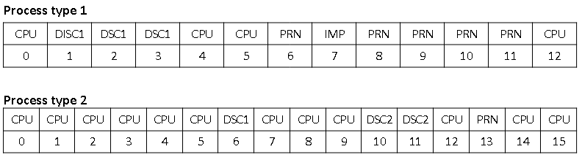

Assuming that the system is running a process of each type, calculate the CPU usage, the average system return time and the waiting time for each job with the following CPU planning algorithms:

* FCFS.
* Round-Robin with quantum=1.

Suppose that the rest of the queues are managed with a FCFS algorithm and that the first process in this system is type 1.

**In your solution, you must provide those elements:**

A) A table similar to this:

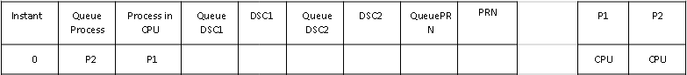

B) These values calculated when process ends:

* **P1 Return time:**
* **P2 Return time:**
* **Mean return time:**
* **P1 queue waiting time:**
* **P2 queue waiting time:**
* **CPU usage:**